CATENA: Soft Self-Folding Chains for Programmable Assembly & Hyper-Redundant Manipulation
Interested students: Sergio Mutis, Wesley She, Alfred Wong, Cecilia Marsicovetere, Manushaqe Muco, S Robert, Alissa Chavalithumrong, George Fajardo

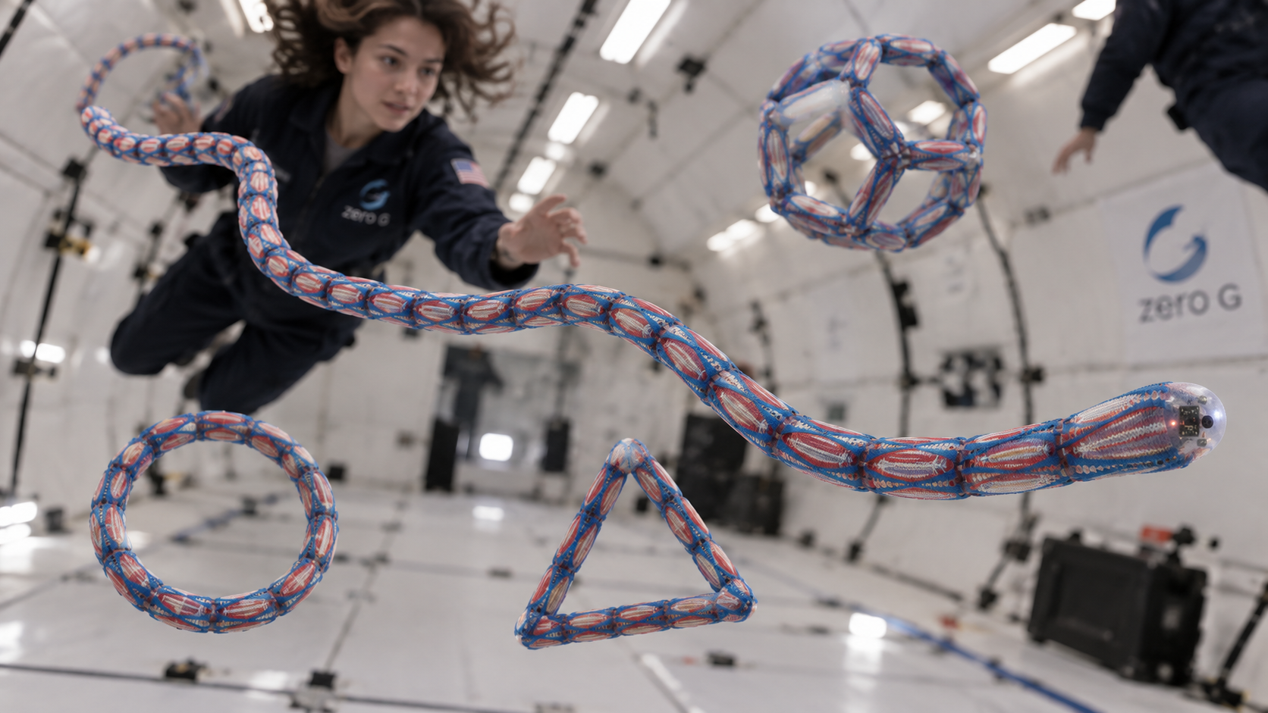

INTRODUCTION / PROBLEM
Current approaches to assembly in reduced gravity, like Aurelia Institute's Tesserae or NASA's Armada Voxels, focus on bringing together, aligning, and locking discrete components, which is extremely difficult in space, where a component's position and orientation change constantly.

CONCEPT / OPPORTUNITY - (What if the components were never separated?)
We propose a soft chain of hinged modules that, like a programmable protein, folds itself into multiple shapes and uses. Because neighbours never separate, their relative position and orientation are fixed by construction, eliminating the docking problem altogether. Each chain has two modes: released, it is a self-reconfiguring structure; anchored at one end, it is a hyper-redundant manipulator.
WHY IT NEEDS MICROGRAVITY
1. Torque Limit. Every joint must hold up every module beyond it, and both the supported mass and its lever arm grow with length, so required torque grows as roughly N^2. On Earth this is a categorical limitation. It has been measured at our module size [2], and it is why our own prototype is twelve modules and not a hundred [9]. Free fall deletes this limit altogether.

2. Attitude control by shape change. Folding one joint makes the rest counter-rotate to hold total angular momentum at zero (the falling-cat mechanism) [4]. So the same final shape, reached through two different fold orders, ends at two different orientations: shape change is steering. This exists only in free fall. On Earth, external torque restrains attitude control.

3. No analog alternative. An air-bearing table is planar; this is a three-dimensional orientation problem. Neutral buoyancy adds drag and mass as large as the effect we want to measure. NASA's own record shows 1g testing misleading on a space manipulator [6]. And free fall is not a stand-in for this test’s environment, it is the environment.
IMPACT
1. Validating never tested theory (Demaine's folding algorithm + attitude control)
Two theories, neither with flight data. Demaine's proof that a chain of simple modules can fold into any shape [1] has never run on hardware at useful length, so we run it and check the commanded shape is reached. Reorientation by internal joint motion has one orbital validation, ETS-VII, a six-joint arm on a large base [10], so we check that a long chain with no dominant base reorients as predicted. The same equations govern an astronaut in free fall [11], but here every mass and angle is known.
2. Volume and Mass Constraints (1 chain replaces every object who's value is its shape)
Cargo to orbit is volume-limited, mass-limited, and stowage is the most-cited lesson across NASA logistics databases. One chain can become any object whose value is its shape: bins, dividers, cradles that wrap irregular items, mounts, brackets, handrails, restraints. A deliverable of this project is the mass and volume trade of one chain against the objects it replaces.
3. Deployment you can undo
Folds are reversible, so a failed fold is a retry rather than a lost mission. JWST flew with 344 single-point failures, about 80% in its deployment sequence, on 178 one-shot release devices. The industry already moved from pyrotechnic to non-explosive actuators to gain testability; reversible folding is the next step, and no one has measured fold-unfold-refold repeatability.
4. Hyper-adaptive Manipulator
Anchored at one end, the chain bends around obstructions and grips by wrapping rather than through a purpose-built fixture. NASA states that the station's arm and Dextre "cannot reach outboard channels (P6, S6)... All work must be performed by EVA crew," leaving 60 boxes and all 48 station batteries to spacewalks, six per flight instead of two [7]. With 11 of 18 suit life-support units left [8], this is triage rather than replacement: a complement to Canadarm2, not a substitute. (*potentially also test Ana Rajcevic's octopus inspired manipulator and draw pros and cons).
THE EXPERIMENT
We list more than we expect to fly. All three share one chain and one set of electronics, and we expect scope to narrow during design. We are equally open to splitting folding (A) and manipulation (B) into two experiments on the same base hardware, whichever suits the campaign.
A. Folding. Fly a chain longer than its own 1g stall length: on the bench it stalls partway, in free fall the identical command completes it. The result is binary and is itself the measurement. We log fold completion versus length at 1.8g, 1g, 3/8g, 1/6g and 0g against the N_max ~ g^(-1/2) prediction, and orientation change per fold from an onboard IMU and video against a pre-flight multibody model [1]. Success is tiered: a stalled chain completing its fold; then orientation within tolerance of prediction; then two fold orders reaching the same shape at measurably different orientations.
B. Manipulation. Anchor one end and command the chain as an arm, measuring whether it holds a commanded pose at all, tip repeatability, available tip force, and reach to a target behind an obstruction. This needs an anchored fixture, so it is a separate rig and A stands alone if only one flies.
C. Learned Body Representation. The chain explores combinations of joint motions and records the resulting whole-body response, building a library that links actions to consequences. We think we can then damage or alter it and test whether it can identify the change and find a new strategy with the remaining modules: recovery by relearning or an algorithm that makes the most out of the chain’s redundancy.
READINESS
Hardware. Working 12-module hardware exists and is published [9]. Missing is the soft damping membrane, IMU, and data logging. We are also considering miniaturization (longer chain, lower mass)
Software. The folding algorithm is ours and already runs. Remaining work is the multibody model that generates the pre-flight attitude prediction, and the logging and telemetry stack.

REFS
- Cheung, K. C., Demaine, E. D., Bachrach, J. R. & Griffith, S. (2011). Programmable Assembly With Universally Foldable Strings (Moteins). IEEE Trans. Robotics 27(4), 718-729.
- Knaian, A. N., Cheung, K. C., Lobovsky, M. B., Oines, A. J., Schmidt-Neilsen, P. & Gershenfeld, N. A. (2012). The Milli-Motein: A Self-Folding Chain of Programmable Matter with a One Centimeter Module Pitch. IEEE/RSJ IROS 2012.
- Mehling, J. S., Diftler, M. A., Chu, M. & Valvo, M. (2006). A Minimally Invasive Tendril Robot for In-Space Inspection. IEEE BioRob 2006.
- Kolmanovsky, I. & McClamroch, N. H. (2000). Attitude control of planar and three-dimensional multibody systems. IEEE Trans. Automatic Control. See also Krishnaprasad, P. S. (1990), Geometric phases and optimal reconfiguration for multibody systems, Proc. ACC.
- Abercromby, A. F. J. & Easter, B. (2022). Lunar Outpost Analogs. In Handbook of Lunar Base Design and Development.
- Bullock, S. & Anderson, T. (2001). International Space Station Design for Dexterous Robotics - Inboard Truss Segments. Space Congress Proceedings.
- NASA (2021). ISS Battery Transition. NTRS 20210011240. See also NASA (2017), Robotics on the ISS and Lessons in Progress, NTRS 20170002575.
- NASA Office of Inspector General (2025). NASA's Management of ISS Extravehicular Activity Spacesuits. IG-25-012.
- Mutis, S., Demaine, E. D. & Tibbits, S. (2025). [Full title]. ACM Symposium on Computational Fabrication (SCF 2025).
- Yoshida, K., Hashizume, K. & Abiko, S. (2001). Zero Reaction Maneuver: Flight Validation with ETS-VII Space Robot and Extension to Kinematically Redundant Arm. Proc. IEEE ICRA 2001.
- Amir, A. R. & Newman, D. J. (2000). Research into the effects of astronaut motion on the spacecraft. Acta Astronautica.
ANEX
Previous research: https://www.sergiomutis.com/mit-universal-folding-chain-robot
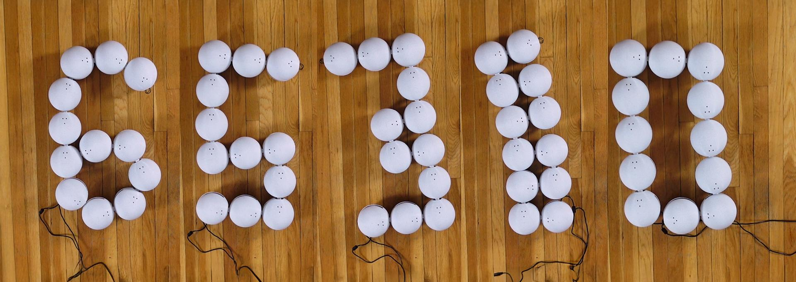
Vision of traditional arm vs hyper-actuated manipulators in reduced gravity